Microsoft 365
  - Security in the Cloud Social Media Copy
Key Hashtags: #Microsoft365
Handle: @Microsoft365
Character limits: Twitter (280)

Social Banner 1
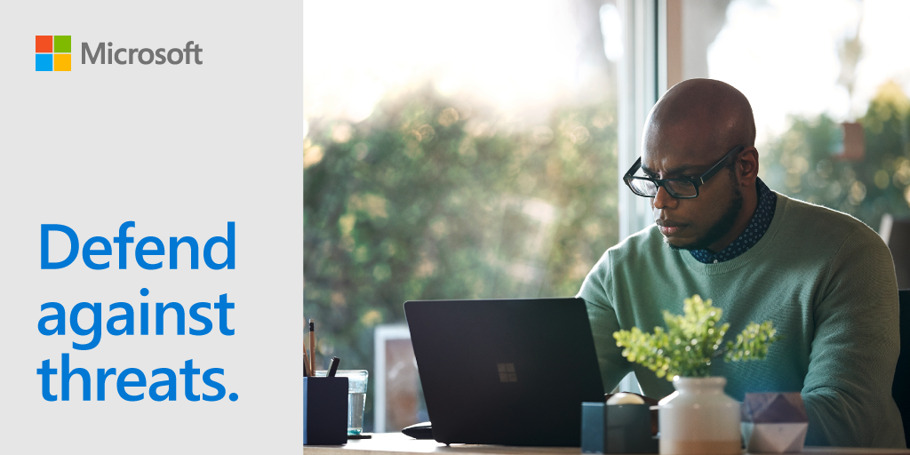

Social copy
If you work at a #SMB, you probably juggle multiple roles every day. Lighten your load with #Microsoft365 and cross off ”become a cybersecurity expert” from your to-do list. | Gone are the days when cybercrime was exclusively a big business problem. As more #SMBs are targeted by hackers, take advantage of advanced security to defend against cyberthreats. #Microsoft365 | Did you know that every day Microsoft analyzes over 6.5 trillion signals to identify new threats around the world? When you get #Microsoft365 from us, you have access to world-class security that stays up to date.

Social Banner 2
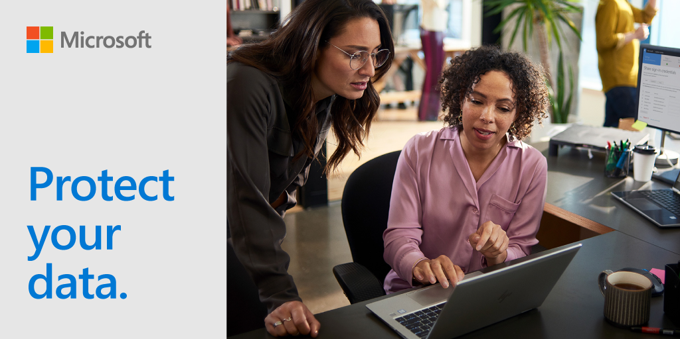

Social copy
Imagine if you emailed your corporate card details to the wrong person… No one wants to be in this situation. Keep your data protected with #Microsoft365. | Protect your email. With #Microsoft365, you can layer and harden your security by encrypting email, restricting suspicious attachments, and protecting your company against data leaks. | 43% of data breaches take place at small businesses. But that statistic doesn’t have to apply to yours. (Verizon) #Microsoft365

Social Banner 3
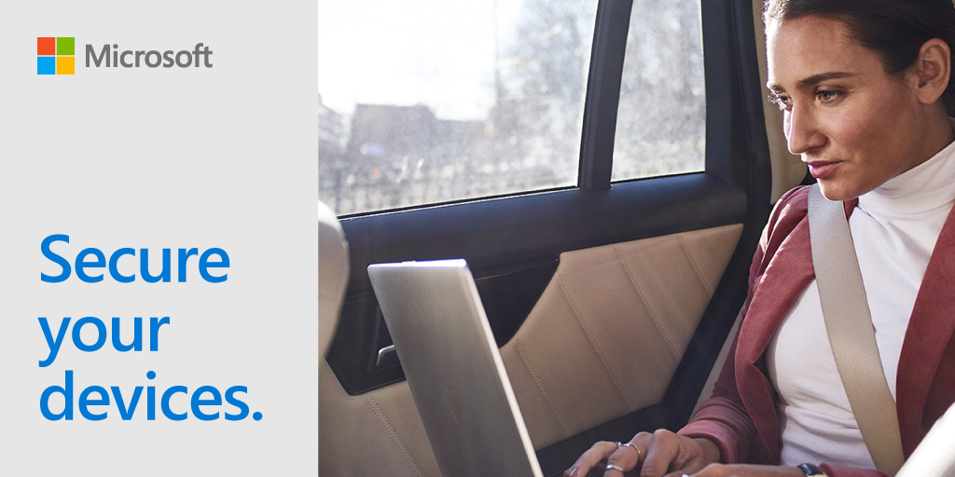

Social copy
Did you leave your phone at the restaurant last night? No need to panic. With #Microsoft365, you can selectively wipe business files and email remotely from any device without affecting your personal data. | Avoid security risks with #Microsoft365 and protect sensitive company information from being leaked on mobile devices.
Whether you’re using iOS, Android, macOS, or Windows devices, we’ve got you covered. #Microsoft365 makes device management a piece of cake. | Today, 60% of cyberattacks come from a breached device. And thousands of other data leaks occur when a device is lost or stolen. It’s time to up your security game with #Microsoft365. Don’t leave your business data unprotected.

