Subject Line: Counter Strategy for Identity Based Attacks

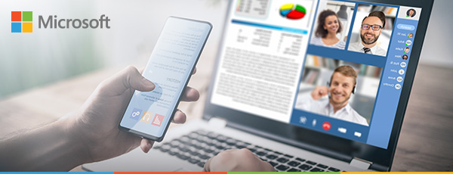

Mitigate the risks of identity based attacks with Modern Workplace with Secure Score

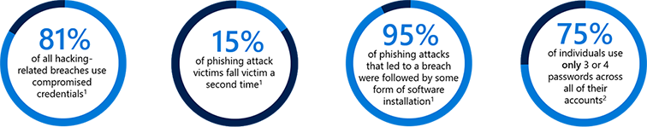
With users accessing your resources from anywhere being the new normal, it’s critical to move from a traditional, perimeter-based network defense to an identity-driven security model.

The threat landscape is continually evolving, and there is an increase in identity based attacks. In fact Microsoft recently confirmed that more than 1.2 Million user accounts were compromised in January. Roughly 99.9% of these accounts could have been protected by adopting modern authentication methods.

We can help you enhance your organization’s security with Microsoft 365 and our Modern Workplace with Secure Score Solution. Microsoft 365 enables your workforce to work together securely from anywhere on any device and it includes all of the Office applications, Windows 10, and Enterprise Security features your business needs.

Modern Workplace with Secure Score helps improve security posture and performance by helping you to identify security risks with the Office 365 environment and recommendations to mitigate potential risks. With it, you can immediately start down the path to improving:
- The security and flexibility of your mobile workforce
- The mitigation of your cyber threats
- The protections on your sensitive data
Interested in a security assessment?
Schedule one today! >

Want to learn more about Modern Workplace with Secure Score and how it can benefit your business? Contact [Reseller] at [email] or [phone].

About [Reseller]

[Reseller Value Prop]

¹ Verizon 2017 Data Breach Investigations Report http://www.verizonenterprise.com/verizon-insights-lab/dbir/2017/
² Security Week Survey

